Why do our footpaths need saving - The History of the Definitive map

When we go for a walk either at home or when we're away, we use footpaths that we always have used, follow marked routes or we grab a map, maybe an Ordnance Survey map and follow the footpaths marked on it.
But not all of the footpaths that we use or can see marked on the map are legal rights of way.

To understand how to save our footpaths we need to take a quick look back in history at how footpaths became rights of way.

In 1932 the first footpath surveys took place for the Rights of Way Act and in 1949 an additional Act of Parliament sought to formalise rights of way further. Over the many years since Rights of Way first became formalised, it became apparent that for many different and varying reasons, many footpaths had been accidentally missed or not documented correctly. In 2000 the government brought forward a new act of Parliament “The Countryside and Rights of Way Act” which contained a section that once again aimed at preserving rights of access.

A small clause within the Act stated all Rights of Way must be properly documented prior to 2026, and those that were not documented properly by that time would be lost forever. In early 2023, due to the length of time the modification process takes and the sheer volume of modifications waiting to be processed, this date was altered and all documentation had to be in order by 2032 In 2025 the current government have abolished this time limit and there is currently no deadline. However, this could easily change again and so it is important ensure all our footpaths are properly documented.

A pathway is classified as a Right of Way when it is officially included on a specific map called The Definitive Map. This map is kept at County Hall and is essential because it designates the routes where the public has a formalised legal right to pass.

The Definitive Map came into existence as a part of the National Parks and Access to the Countryside Act 1949, which required counties in England and Wales to document public paths; each County Council tasked local parish or district councils to survey and decide which pathways should be noted as Rights of Way.

In Wiltshire they used Parish Claim Map (Fig1.) – this was provided as a blank map for parishes to mark with footpaths, and individual Record Cards (Fig 2.) - to note start and finish points, width and usage of footpaths they wished to be on the map.

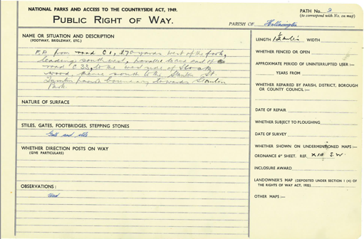
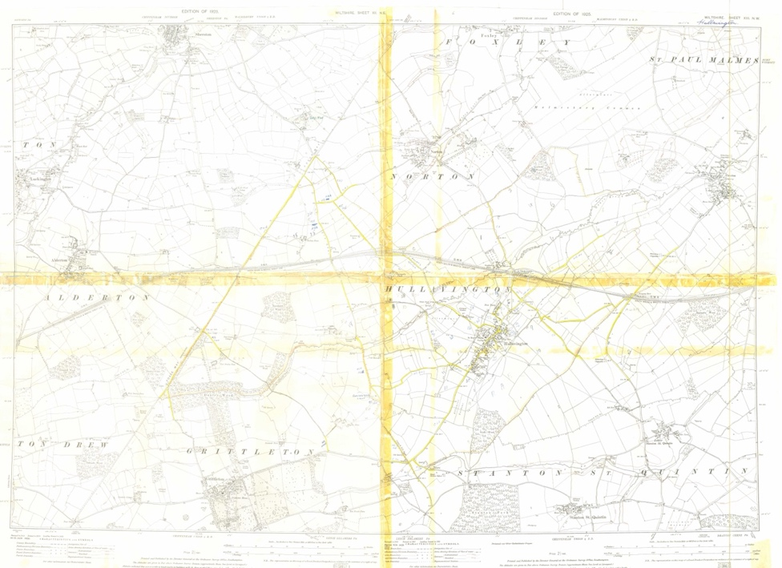
Fig 2 Parish Claim Record Card – click to enlarge

Fig.1 Parish Claim Map for Hullavington - click to enlarge

The information received from each parish was sent to the County Surveyors Office.

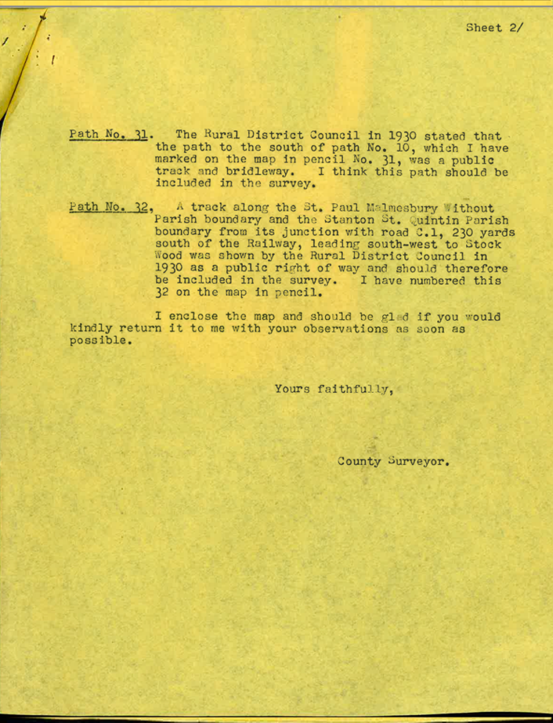

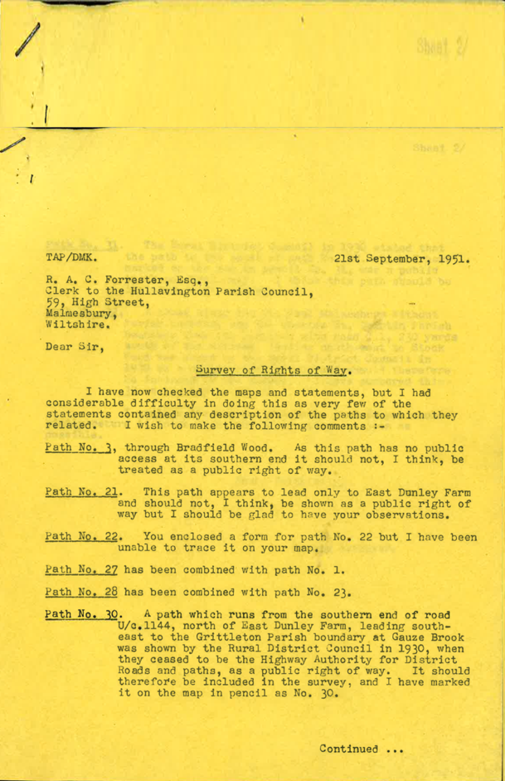

The County Surveyors then checked and clarified the information, both in person and by writing to the parish (Fig 3 above) and finally a draft was produced (Fig 4)

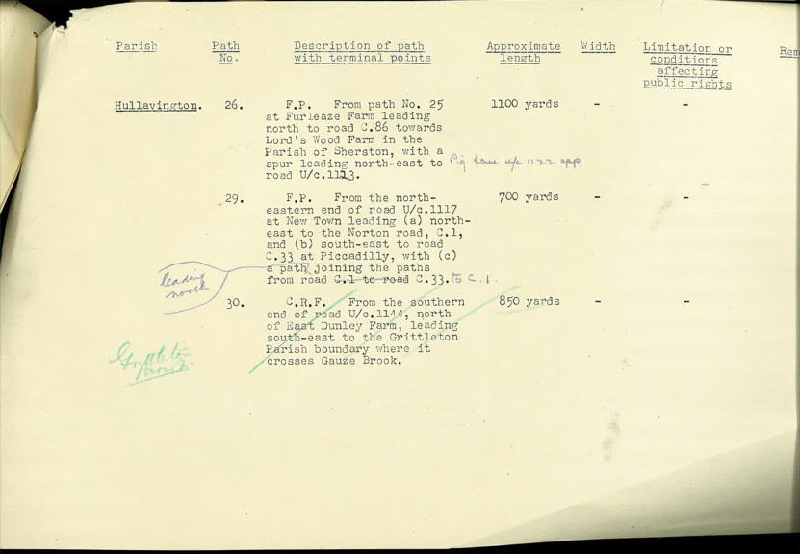

Fig 4.Draft Definitive Statement for Hull 26 - 30

Once the route, start and finish points, types of boundary etc had been finalised and agreed the claims map and record card were formally recorded and used to make the Definitive Map (Fig 6.) and the Definitive Statement (Fig 5) for each Parish
The first draft of the Definitive statement for Hullavington, with corrections made is shown above with the currently Definitive Statement below

Fig 5. Definitive Statement for Hullavington click picture to see entire Definitive Statement
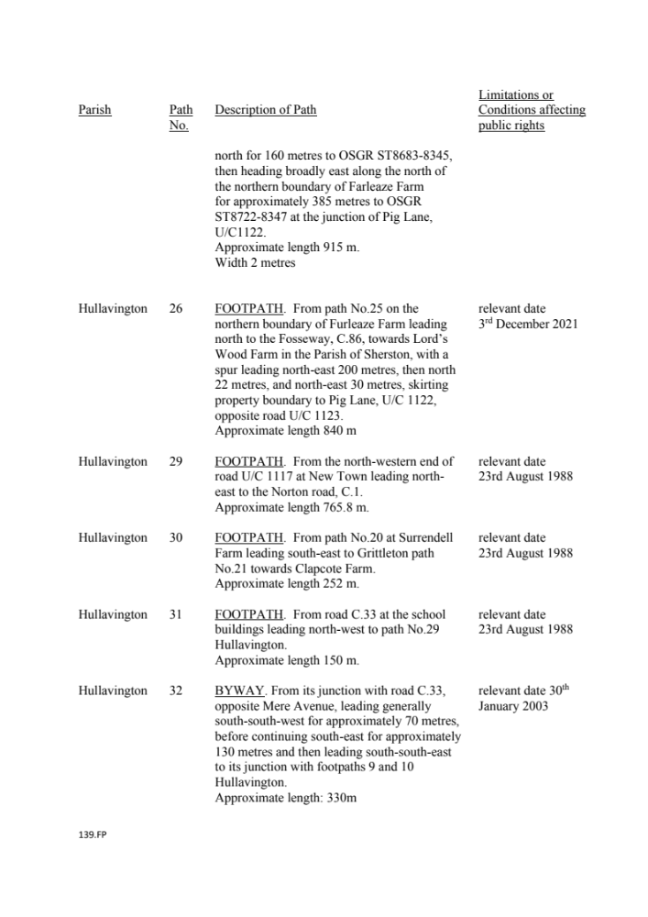

The information the parishes once collated was used to construct the Definitive Map.

The Definitive Map is a hardback book of maps covering the whole county recording all the legal rights of way, and it is the original map book as was first constructed in the 1950s.
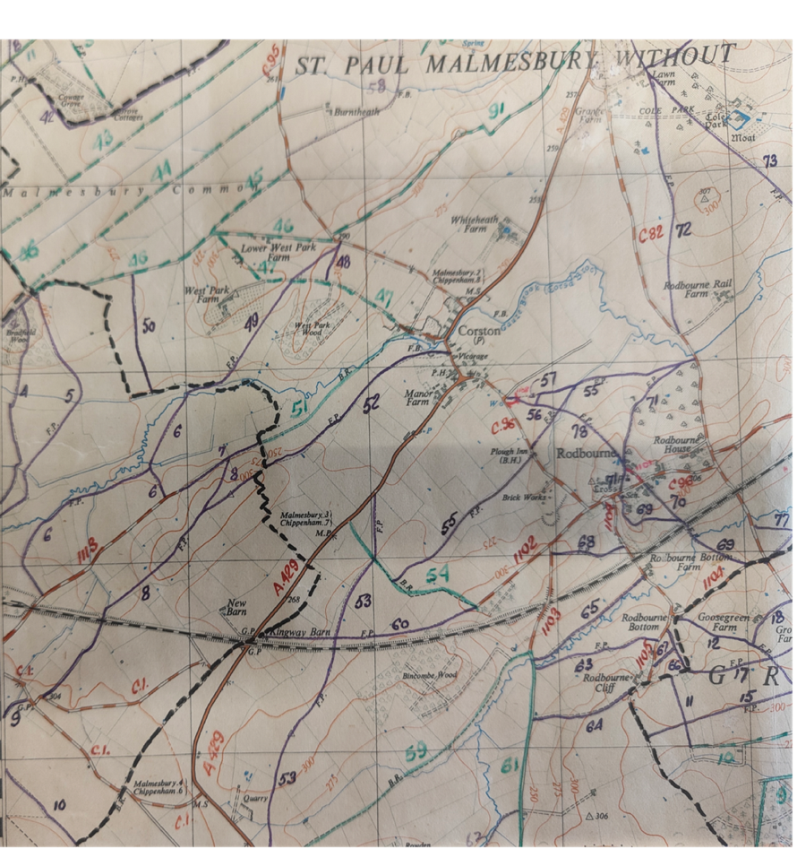
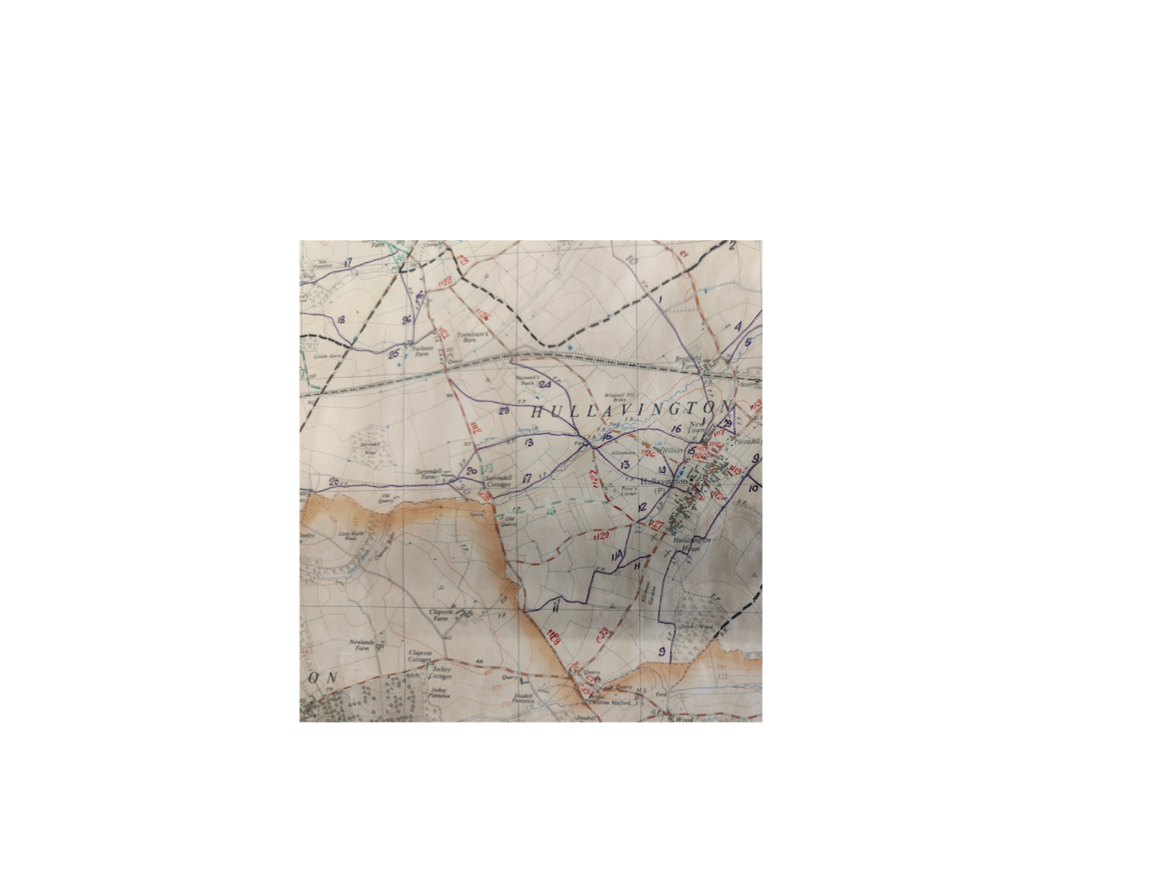

Fig 6. Definitive Map for Hullavington click picture to enlarge\

Why are some footpaths not recorded properly as rights of way?

Parishes were not infallible they mainly relied on word of mouth and current usage to decide which footpaths to put forward for the definitive map, in some cases the councils were led by the land-owners and farmers who claimed footballs to be private driveways or of a over lower status than they had previously been ie Bridleway -> footpath. In some in some cases they felt they had too many footpaths and didn't want the upkeep and so those that were used to lesser degree were not put forward.

Nor did they consider in most cases any historical evidence such as the Finance Act Land Map of 1910 or the Electricity Supply Acts 1882 to 1922 (these were proposals to lay cables under roads) these records we're not locally held making them completely inaccessible, even if the parish council had known about them.

